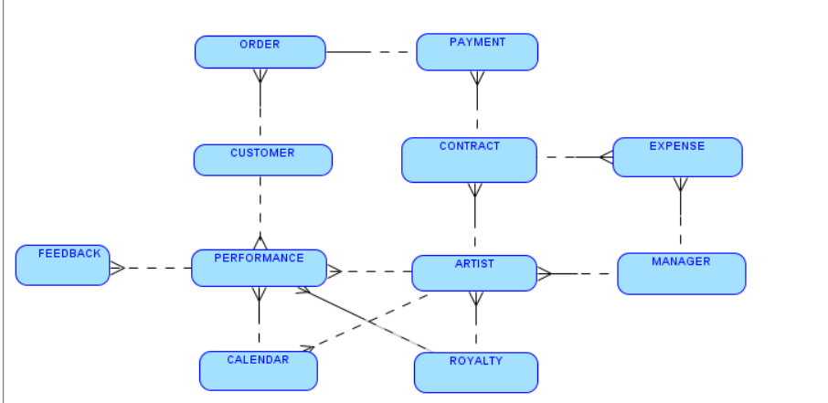

1. Artist: This entity represents classical music artists. It would include attributes like artist ID, name, contact information, and performance history.

2. Manager: The manager entity represents the artist managers at FAME. It would have attributes like manager ID, name, contact details, and the number of artists they manage.

3. Contract: This entity represents the contracts between FAME and the artists. It would include details such as contract ID, start date, end date, and terms.

4. Performance Opportunity: This entity tracks performance opportunities, including the venue, date, and artist requested by the customer.

5. Customer: Represents opera houses and concert halls who request artists for performances. Includes customer ID and contact details.

6. Expense: Records various expenses incurred during artist management, such as flyers, photos, prints, and advertisements.

7. Payment: Tracks payments received from customers for performances.

8. Royalty: Records the royalties earned from performance fees. It includes details such as royalty ID, amount, and the artist it's associated with.

9. Calendar: Represents the artist's performance schedule, including dates, venues, and availability.

10. Feedback: Stores feedback and reviews from customers or critics about artists' performances.

Relationships:

1. Artists have contracts, and each contract is associated with a specific artist.

2. Managers manage multiple artists, establishing a one-to-many relationship between Manager and Artist.

3. Contracts are between FAME and Artists, creating a many-to-many relationship.

4. Performance opportunities are requested by Customers, creating a relationship between Customer and Performance Opportunity.

5. Expenses are associated with Contracts, and Payments are associated with Contracts as well.

6. Royalties are earned from performance fees, linking Royalty to Performance Opportunity.

7. Calendars track the schedules of Artists, connecting Calendar to Artist.

8. Feedback can be associated with Artists or Performances, creating a relationship between Feedback and Artist/Performance Opportunity.

This represents a simplified outline of the entities and their relationships. In practice, the data model may include additional attributes and complexities depending on the specific requirements of the database solution being proposed for FAME Inc.